Explanation

- The idea is to add ')' only after valid '('
- We use two integer variables left & right to see how many '(' & ')' are in the current string
- If left < n then we can add '(' to the current string
- If right < left then we can add ')' to the current string
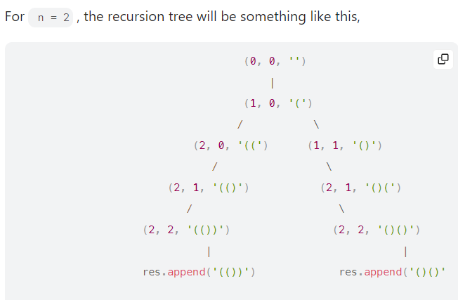
Intuition
Increase number of open parentheses until we reach n at first
Approach
Let's think about n = 2.
n = 2
well-formed parentheses:
()()
(())
We have open parentheses before close parentheses. That's why my strategy is to increase number of open parentheses until n at first, then increase number of close parentheses until n.
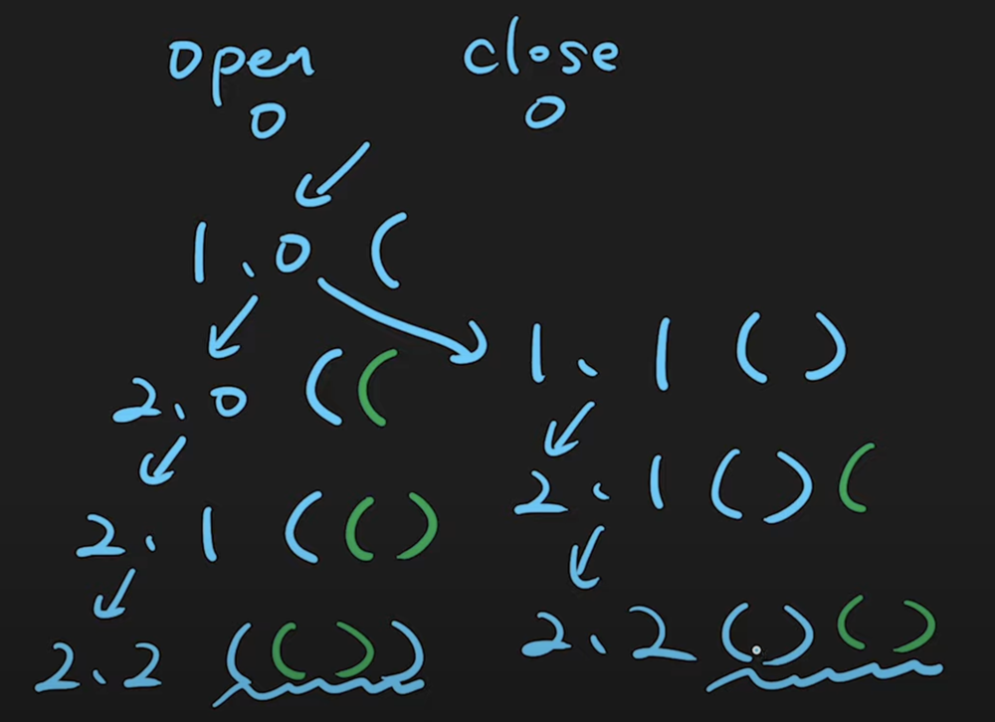

2nd Way of explanation:
Problem Description
The problem requires us to generate all possible combinations of well-formed parentheses given n pairs. A well-formed combination of parentheses means that each opening bracket "(" has a corresponding closing bracket ")", and they are correctly nested. To better understand, for n=3, one such correct combination would be "((()))", whereas "(()" or "())(" would be incorrect formations.
Intuition
To arrive at the solution, we need to think about how we can ensure we create well-formed parentheses. For that, we use Depth First Search (DFS), which is a recursive method to explore all possible combinations of the parentheses.
- We start with an empty string and at each level of the recursion we have two choices: add an opening parenthesis "(" or a closing parenthesis ")".
- However, we have to maintain the correctness of the parentheses. This means we cannot add a closing parenthesis if there are not enough opening ones that need closing.
- We keep track of the number of opening and closing parentheses used so far. We are allowed to add an opening parenthesis if we have not used all n available opening parentheses.
- We can add a closing parenthesis if the number of closing parentheses is less than the number of opening parentheses used. This ensures we never have an unmatched closing parenthesis.
- We continue this process until we have used all n pairs of parentheses.
- When both the opening and closing parentheses counts equal n, it means we have a valid combination, so we add it to our list of answers.
Look at the code in “Generate Parentheses_approach2.java” file. The code uses a helper function dfs which takes 3 parameters: the number of opening and closing parentheses used so far (l and r), and the current combination of parentheses (t).
By calling this function and starting our recursion with 0 used opening and closing parenthesis and an empty string, we will explore all valid combinations and store them in the list ans.

